University of Pittsburgh at Johnstown

Electrical and Computer Engineering Department SENIOR DESIGN COE1199

Cycle Statistic Tool

Weekly Memorandum
To: | Maddumage Karunaratne
From: | Jacob Hoffman  Cody Klingler

cc:
Date: | 04/22/2021

Re:

Achievements:

Cody: The bike was ridden with the devices for the first time. I finished the primary microcontroller code and secondary microcontroller code. I reconfigured BLE to allow multiple devices to connect to one another. Found a temporary solution to power the secondary microcontroller with AA batteries until we have a 5V voltage regulator. The hardware was mounted in the project box and attached to the bicycle. The functional requirements were also tested.

Jacob: Cody and I have made a tremendous amount of progress this week, it is a good thing we met up in person to finish the project! Within the project logbook entries, I have provided descriptive documentation of our time spent this week. To save on time and space, I am going to provide a list of achievements this week:
- Redesigned the GoalProfile database.
- Completed the Goals page. The user can create/edit a goal profile.
- Redesigned the BluetoothViewModel.cs class (bluetooth LE client).
- Made BLE connectivity work, as well as dynamic data display, by implementing the following:
  - Connect to a CST device by selecting it from a list of nearby devices.
  - Read a list of services from device and decompose to the necessary services
  - Read a list of characteristics from each service and concatenate them together.
  - Connect each characteristic by the ValueUpdated property to its corresponding event handler (These are handled asynchronously) .
  - Dynamically saved the values being broadcasted into a data model that is being observed by the UI.
- Set up the start, stop/clear, and finish buttons on the Trip page, as well as a timer for recording elapsed time during a trip.
- Due to the change in the GoalProfile database, the Settings page needed re-coded. It currently allows the user to delete the GoalProfile database or Trip database entries.
- Lots of UI tweaks that make the app experience much smoother/faster. This also helped lower the amount of steps to begin a trip (functional requirement).
- Lots of debugging.

Issues Encountered and Solved:

Cody: BLE doesn’t permit a peripheral (slave) to connect to multiple centrals (masters), but we need to connect multiple BLE devices. The phone couldn’t be a peripheral because there is no xamarin library to support it. The solution was to use a flaw in Arduino's BLE implementation that allows a device to be both a peripheral and a master. Most of the GPS crashing was fixed. One was caused by an uninitialized array and the other by poor implementation of the parsing library.

Jacob: At the beginning of the week, we were having issues with bluetooth connectivity. Cody showing up at my apartment with the hardware in person dramatically improved our rate of resolution for issues between the arduino hardware and the application. We ended up resolving the connectivity issues and can dynamically display data on the app now. Later in the week, we had other issues that stemmed from the arduino hardware which required Cody to send all the data over three services instead of one. Because of this, I had to implement a Services list in the BluetoothViewModel and use that to connect all of the characteristics.

Issues Encountered and Unresolved:

Cody: The protoboard for the main circuit doesn’t work. Testing with a multimeter shows that my female headers are shorted with resistance of ~20 M Ohm. I have soldered new headers multiple times and it wont work. Going to use a breadboard, but this shouldn’t be used permanently. Also, sometimes the GPS gives garbage data that causes a crash. I don’t know why this is, but it occurs very infrequently. Sometimes the primary microcontroller fails to start, but this can be rectified by trying again.

Jacob: The SQLite database for saving the Trips to the user’s device is fundamentally flawed. Within each Trip object, I currently have a List<RecordedData> entry called TripData. However, SQLite is incapable of saving a list into a table. I have not resolved this issue yet, but I plan on saving from ble directly into a table, instead of a trip object. Or, I am planning on trying to save a table within a table, i.e. replacing the TripData list with a table embedded within the Trip object.

Goals and Tasks For Next Week:

Cody: We will work on the final report for the project.

Jacob: The final presentation for the project is on 04/20/21. Cody and I plan on presenting the Cycle Statistic Tool in-person at the school, so leading up to this date, we will most likely be testing portable usage, and we will potentially bring the bicycle to the school for storage. After this, the project team will need to prioritize the final report for the project, but if there is time for working on the application, I plan on working on implementing the performance page to display charts for each parameter being recorded from the CST hardware. Additionally, I will work on resolving the current issues with the Trips database.

Project Schedule:

Cody: The deadline for the project had been reached with unfinished tasks. We never weather proofed the device or implemented the wind sensing unit.

Jacob: We have covered a large amount of ground this last week. All things considered, we did a lot of debugging. The application still needs one page to be implemented--the performance page--but, just about everything else is complete. However, this technically would mean the project is still coding the mobile application, so we are behind on that. We are still doing general testing, but the bluetooth connectivity has been implemented and tested for accuracy.

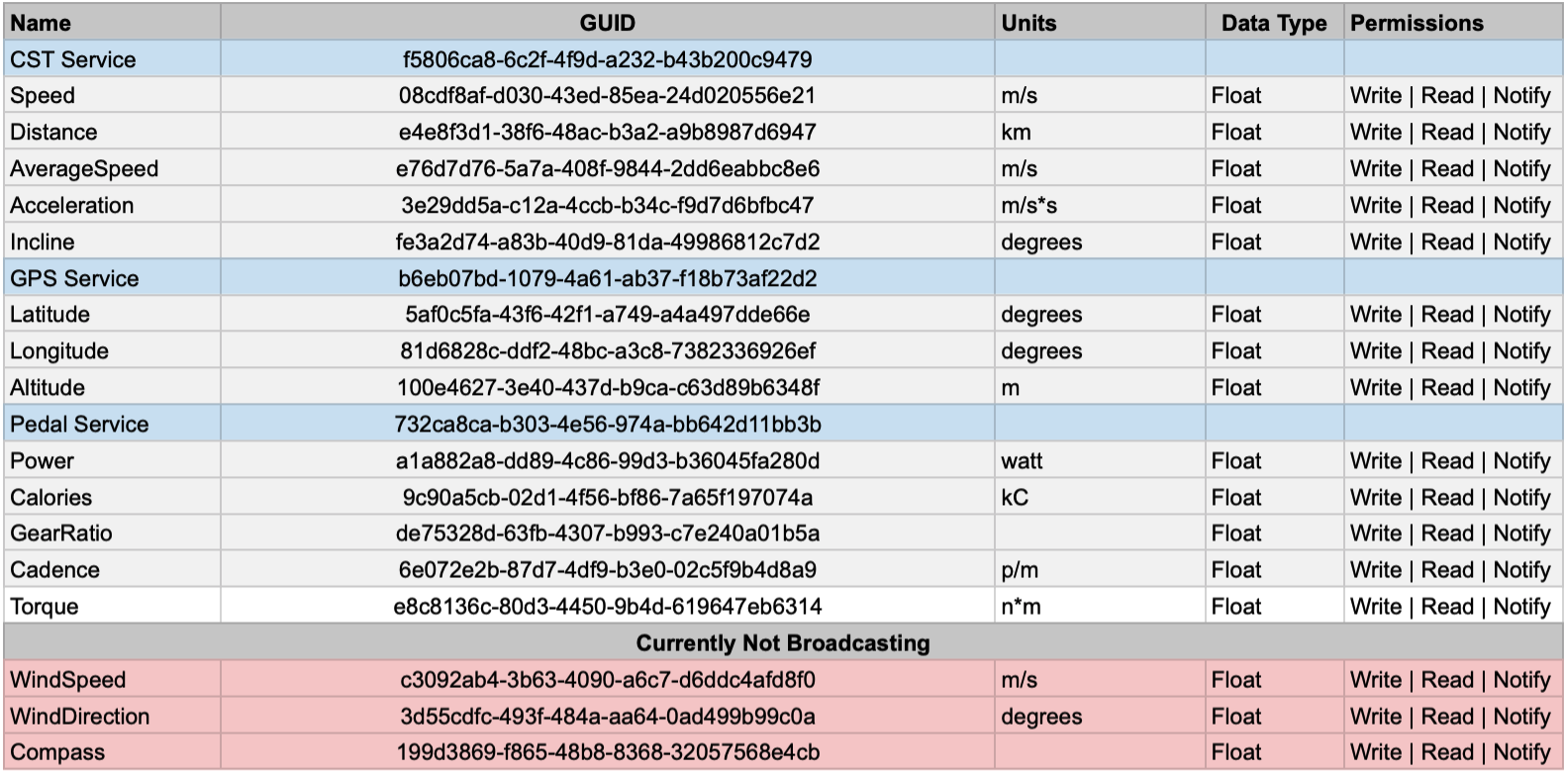
Figure 1: Updated GATT Attribute Table

Project Logbook:

Cody:

4/13/2021 - 12.5 hours
Fixed GPS BLE crash. I forgot to set the size of an array, which was causing a memory access error.

4/14/2021 - 12.25 hours
broke secondary microcontroller - ordered two new ones. i had a spare and it stopped working even though we weren't using it.

4/15/2021 - 10.75 hours
finalized display code, passed rolling averages to display. The float values now keep the same amount of digits depending on magnitude. 99.345 -> 101.57. added code that disables the display when it isn't being used to it draws significantly less power.
The GPS wasn't starting when the display was added. This was eventually fixed, but I'm not sure how. (note: looking back, I think it was a faulty connection to the GPS) Fixed some rolling average code.

4/16/2021 - 13.5 hours
Currently you cant connect two devices over BLE to the CST. I fixed this by setting the primary device to a central and peripheral. Tested this stuff for most of the day.

4/17/2021 - 16.0 hours
Set up the rest of the characteristics (the ones based on secondary microcontroller) and passed the data from the secondary to primary. Wrote code to calculate power, cadence, angular velocity, calories burned

4/18/2021 - 19.5 hours
I spent the entire day soldering protoboards to interface all of the parts of the primary microcontroller. I troubleshooted the board for hours, but the female headers for the display kept shorting by 20 M Ohm. I just put everything on a breadboard instead.

4/19/2021 - 13.5 hours
Mounted the hobby box with the breadboard. The battery pack that we were using wouldn’t work, so I spent most of the day running around soldering batteries until I found something that would work. The input voltage of our arduino is supposed to be 3V to 21V, but it seems to want something close to 5V. The only thing that worked was 3 AA batteries soldered in series for an output of 4.5V. even 6V was too much. We also rode the bike and took videos for the presentation.

Jacob:

04/13/21 - 12 hours

I spent a decent amount of time today designing a new database using SQLite based on a few tutorials I had found on the internet. I put a lot of work into this in an attempt to solve the null reference exception error I was getting yesterday. Unfortunately, I am getting the same error, even with a completely different design for the database. I am kind of sad because I don't really know why this started happening. The database had been working perfectly fine, if I remember correctly. I had not really messed with it in a while. Eventually, Cody and I tried setting up the bluetooth connection some more, but we were only able to get the phone connected to the device. Another null exception error is occurring at run-time, but this is occurring whenever the device tries to connect to the service and subsequently get, then use the characteristics in code and it crashes (null exception error).

04/14/21 - 9 hours

I woke up early and started re-designing the bluetooth client inside of the application. I implemented a list for collecting characteristics and started using the other methods that are baked into the Plugin.BLE Nuget package. The main method returned a list of characteristics from the service instead of us manually calling each characteristic. After finishing up the new code, we were still having issues with the phone connecting to specifically the service broadcasted by the BLE device. I am still dealing with this issue.

04/15/21 - 6.5 hours

I ended up getting the BLE View Model to work. Now, I am able to connect to a service, connect to all characteristics, asynchronously startupdates, and all characteristics have their value updated being handled. The Trip view is now able to dynamically display the data from the Cycle Statistic Tool.

04/16/21 - 13 hours

I set up a stopwatch and timer for keeping track of saving a trip. Additionally, I wired up all of the buttons on the trip page for their appropriate functionality. I started working on getting the databases completely working, but I still am working on this. Also, at the beginning of the day, some debugging was done on the binded data and it seems to be working better. Cody and I also did a lot of testing.

04/17/21 - 6 hours

I ended up working on the powerpoint slides for our presentation. Additionally, I converted my project logbook entries into timesheet entries, and I also did this for Cody. After this, I calculated the cost analysis for our senior project. Cody and I also did some debugging.

04/18/21 - 9 hours

I made the goal profiles database functional. Additionally, the goals page is complete. The user can now add/edit goal profiles. Because I re-designed the goal/trip databases, the settings page needed new code, so I also fixed that and made the delete all buttons functional. The trip page needed to be updated to accommodate Cody changing the GATT table. He needed to extend the amount of characteristics we are sending across multiple services. This took some time to figure out, but the application is once again able to dynamically display the data received from the primary CST microcontroller. Today I also started writing code for the performance page. I realized that my implementation for the trips SQLite database is flawed and will not work. SQLite tables cannot store list parameters, but I currently have a list object for the TripData within each Trip object (the data model attempting to save into the trips database). This must be resolved so the application can store and display saved trips. Perhaps I can store a table within a table (instead of a list for tripdata)? I am still working on this, but I want to hopefully implement a pop-up performance page that displays a plot vs time for each parameter being sent from the CST, but without saving being implemented. Then, I just need to resolve the database issue and I am good to go. If I can find some free time, I will implement this. Otherwise, Cody and I will be doing testing on 04/19/21 and will have our final presentation on 04/20/21.

Task Division:

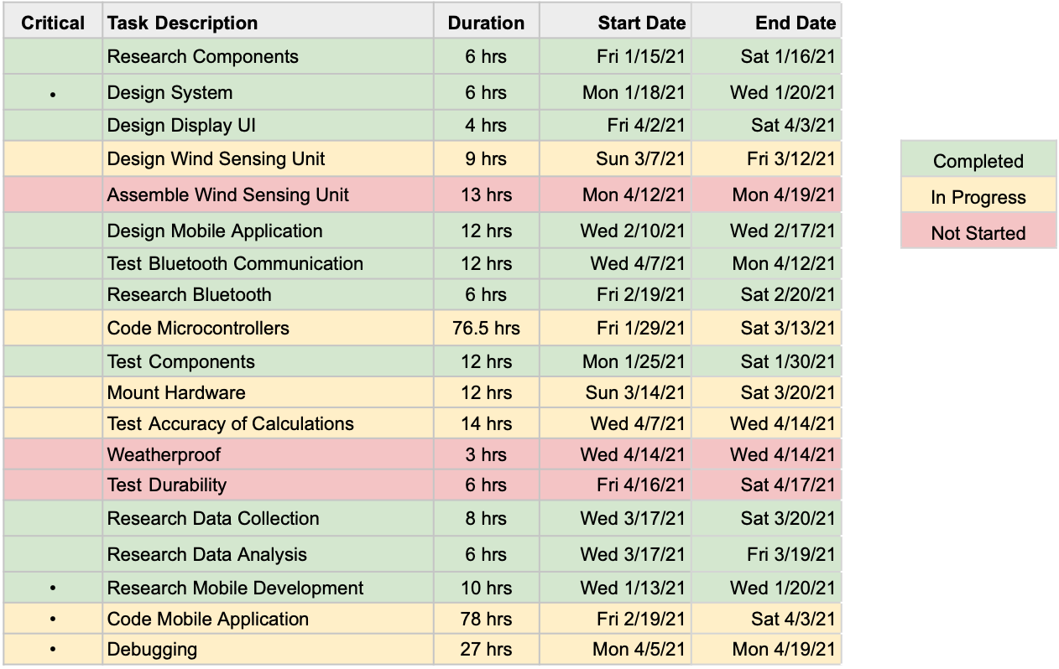
GANTT Chart:

